Chapter IV: Presentation and Analysis of Data
- System Architecture
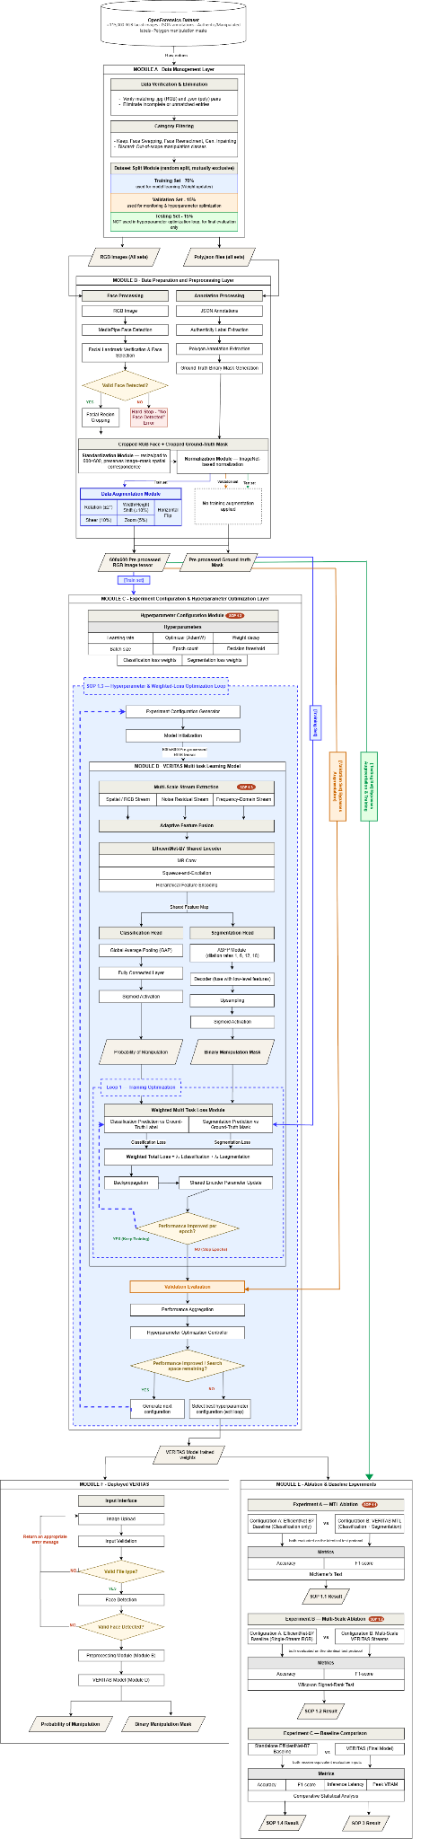
Figure 4.1: System Architecture
- Description of Modules and Interfaces
The VERITAS system architecture presents the complete workflow of the proposed forensic image analysis system, integrating dataset management, preprocessing, model development, optimization, evaluation, deployment, explainability, and forensic reporting into a structured sequence of interconnected modules. The architecture is divided into two distinct environments: the Offline Research and Training Environment, where Modules A through E use annotated data for training, validation, hyperparameter optimization, model selection, and controlled experimentation, and the Deployed Inference Environment (Module F), where the finalized model processes user-supplied images without access to ground-truth annotations. This separation ensures that the model is scientifically evaluated without compromising the integrity of the held-out Testing Set, while also reflecting the conditions of actual forensic use. The deployed system performs face detection, preprocessing, multi-scale feature extraction, manipulation classification, localization, and explainability before presenting the results through the VERITAS Forensic Analysis GUI and consolidating them into a human-readable forensic analysis report. In addition, the architecture incorporates training, hyperparameter optimization, model selection, and research comparison feedback loops, establishing a direct connection between the system's computational processes and the study's experimental objectives and Statements of the Problem.

- Data Management Layer
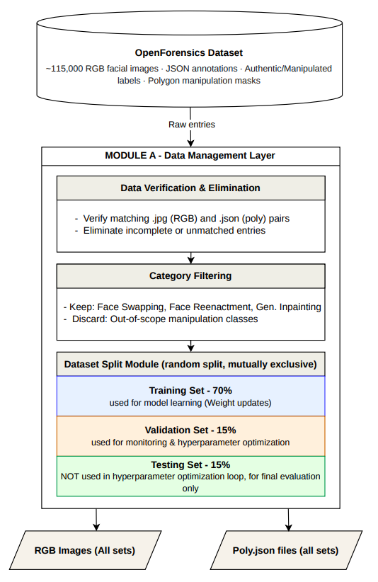
Figure 4.2: Data Management Layer
The OpenForensics dataset is the only external input to the Data Management Layer, which consists of over 115,000 facial images with annotations, annotated files (in JSON format), authenticity labels, and manipulation masks (polygons) (Le et al., 2021). A Verification and Filtering Module validates all entries from the raw RGB image to ensure that a raw RGB image is always accompanied by a JSON poly file, preventing an incomplete supervision signal from going through the other modules. Entries in the remaining classes are then only allowed for manipulation in one of three techniques: face reenactment, face swapping, or generative inpainting. Entries that do not fall into these classes are removed from the pool of entries, and the balance of the classes is preserved by keeping real images in their original state.
The Dataset Split Module is designed to separate the validated and filtered dataset into three mutually exclusive data sets that are used for three purposes: First, to train the model and adjust the weights (Training Set 70%); Second, to verify if the developed model and its hyperparameters are generalizing to the real population (Validation Set 15%); and Third, to measure the final model performance (Testing Set 15%). This separation is not only incidental, but the Testing Set is routed directly to Module E (Ablation and Baseline Experiments), completely bypassing the training and optimization loops of Modules B, C, and D, and is read only once at the end of the research process for unbiased evaluation. With this decision, the performance reported by VERITAS is guaranteed to be a truthful estimate of generalization, in accord with the validation protocol described in Chapter I, and with previous studies on the same benchmark (Eilia et al., 2025). The other two outputs of the layer are the Training Set and Validation Set inputs to be used in pre-processing in Module B.

- Data Preparation and Preprocessing Layer
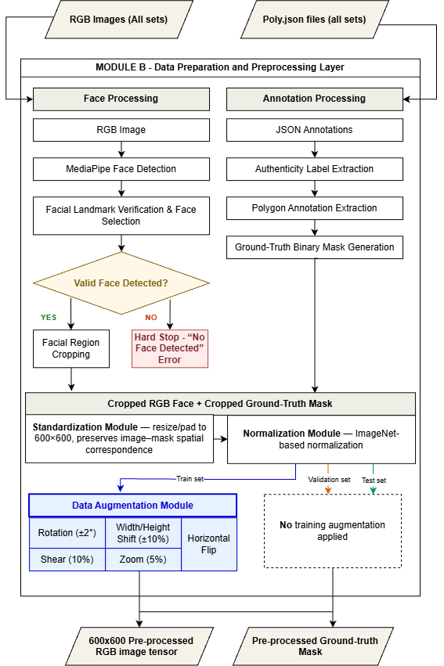
Figure 4.3: Data Preparation and Preprocessing Layer
The entries forwarded by Module A to Module B are the Training Set, Validation Set, and Testing Set entries, and the following description focuses on the processing applied to a single data entry, as all three sets of entries are passed through Module B without any differences beyond the addition of augmentation at the end. Because raw OpenForensics images frequently contain multiple faces with distinct face-level annotations in poly.json (where a single frame may contain both authentic and tampered individuals), processing is executed at the individual face level. Each raw image first undergoes Face Processing using the MediaPipe Face Detection algorithm and bounding box coordinates to isolate all face instances within the frame. If no valid facial structure is detected, a 'Hard Stop' returns a 'No Face Detected' error to prevent malformed data from advancing. Following face extraction, Annotation Processing decodes the corresponding polygon annotations matching each face ID, generating a face-aligned Ground-Truth Binary Mask (600 x 600) and a definitive face-level authenticity label (Authentic vs. Manipulated). This sequence ensures that multi-person scenes containing mixed real and fake subjects are converted into discrete, independently evaluated facial samples.
The cropped pair then goes through the Standardization Module, which resizes/pads both tensors to the 600×600 resolution required by the EfficientNet-B7 encoder, and the Normalization Module, which applies an ImageNet-based normalization to the image tensor. The Training split is augmented with a Training Augmentation Module, which consists of rotation (±2°), width and height shifting (±10%), shearing (10%), zooming (5%), and horizontal flipping; validation and test entries are not augmented to preserve an unbiased measurement surface. Module B's output is therefore twofold: a pre-processed RGB tensor, being passed forward as an input into Module D, and a pre-processed Ground-Truth Binary Mask tensor, which is not passed forward for use in the encoder, but is instead saved for evaluation and used in Module D's Weighted Multi-Task Loss component during training, as well as in Module E's ablation and baseline experiments to calculate segmentation metrics.
- Experiment Configuration and Hyperparameter Optimization Layer
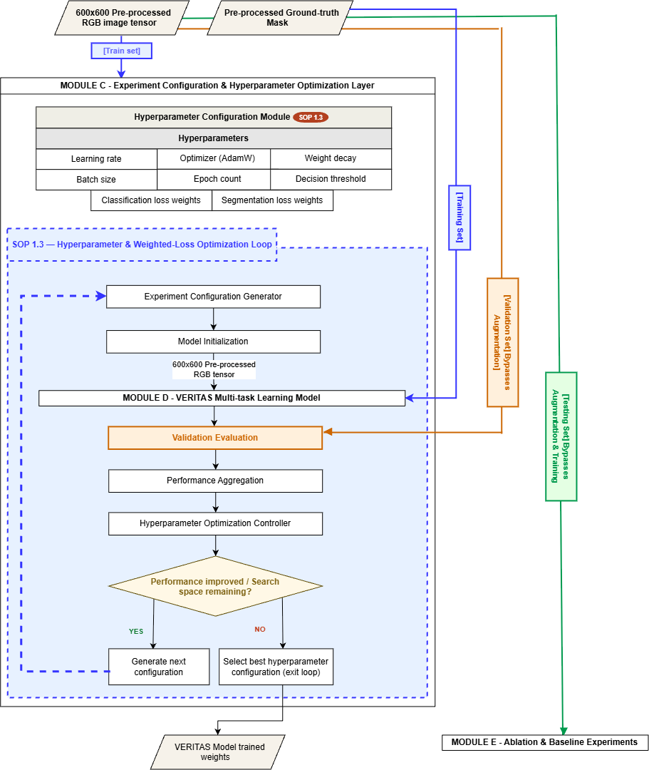
Figure 4.4: Experiment Configuration & Hyperparameter Optimization Layer
The search in Module C takes two inputs: the pre-processed data passed on by Module B that provides every Training Run, and the validation performance feedback returned by Module D at the end of each training iteration. This layer is not included in the original Conceptual Framework but is added to formalize SOP 1.3 by simply allowing the hyperparameters of the model (learning rate, optimizer, weight decay, batch size, epoch count, decision threshold, and, importantly, the classification and segmentation loss weights λ₁, λ₂) to be experimental variables rather than constants (Tan & Le, 2019). The architecture leaves the AdamW optimizer (learning rate = 1e-4) as the default training parameter, and all other training parameters are similarly available to a recursive Hyperparameter Optimization Loop.
The loop continues as follows: An Experiment Configuration Generator generates a configuration, initializes a new model instance, then runs a Training Run; the resulting model is evaluated on the Validation Set, and the performance of the model is combined by a Hyperparameter Optimization Controller. If the performance has improved, or if there is still search space, then a decision point evaluates whether the performance has improved, and if it has, the controller generates the next configuration and the loop returns to Model Initialization, repeating for Trial 1-Trial N. The Best Hyperparameter Configuration is selected and used in Module D to train the Final Candidate Model, whose optimized weights are packaged and transferred directly to the evaluation experiments in Module E and the deployment engine in Module F. None of the held-out Testing Set is ever used in this loop, thereby validating this protocol as laid out in Chapter I.

- VERITAS Multi-Task Learning Model
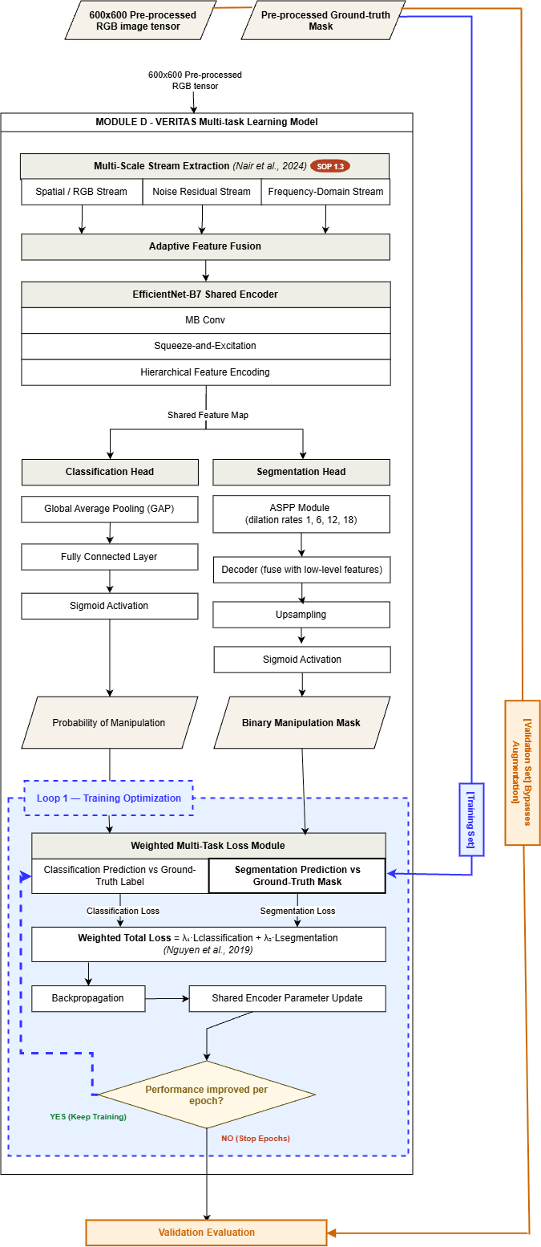
Figure 4.5: VERITAS Multi-Task Learning Model
Module D is given three inputs, namely: the pre-processed 600x600 RGB tensor and the corresponding Ground-Truth Binary Mask, both passed from Module B, and the Best Hyperparameter Configuration selected by Module C, which controls the training run itself.
The VERITAS model implements the Encoding, Classification Head, and Segmentation Head stages of the Conceptual Framework, modified by adding the multi-scale stream architecture demanded by SOP 1.2. The RGB tensor is simultaneously fed into three parallel streams of extraction, namely the Spatial/RGB stream, the Noise Residual stream, and the Frequency-Domain stream, following the Multi-scale Stream Extraction Theory described in Chapter I. These streams are fused together in an Adaptive Feature Fusion module into a Unified Feature Tensor, passed to a common EfficientNet-B7 encoder. The output of the encoder is a hierarchical Shared Feature Map, which is fed identically to both downstream heads, representing the shared-encoder principle of Multi-Task Learning Theory.
The shared feature map is reduced using Global Average Pooling, and the resulting vector is processed by a fully connected layer with a sigmoid activation function, resulting in a Manipulation Probability Score in the range [0, 1], where a threshold of 0.5 is used to determine the binary Authentic/Manipulated verdict.
The Segmentation Head, on the other hand, is a spatial resolution saver. The shared feature map is fed into the Atrous Spatial Pyramid Pooling (ASPP) module at four different dilation rates, corresponding to 1, 6, 12, and 18, plus a Global Average Pooling (GAP) branch, as proposed by Chen et al. (2018); rate 1 recovers fine boundary artifacts, and the higher rates capture wider semantic inconsistencies. The combined ASPP output is then projected and fed into a decoder that combines it with low-level encoder features, and then progressively upsampled to 600x600 resolution and passed through a sigmoid activation to generate a pixel-level manipulation probability map and a Binary Manipulation Mask at a 0.5 threshold.
The Weighted Multi-Task Loss component in training compares the Manipulation Probability Score and the Binary Manipulation Mask with their ground-truth reference (manipulation authenticity label and Ground-Truth Binary Mask provided above) to obtain a Classification Loss and Segmentation Loss. They are added together to form a Weighted Total Loss (L_total = λ₁·L_classification + λ₂·L_segmentation), where λ₁ and λ₂ are not constant, but are considered variables and will be optimized by the optimization procedure of Module C. The weighted total loss is then back-propagated through the shared encoder, with the parameters adjusted and Loop 1 (Training Optimization) closed for this iteration.
The outputs of Module D vary with context. Its outputs during training include the loss value, passed back to Module C as the validation-performance signal that is used in the Hyperparameter Optimization Loop to update the weights of the Encoder, and the updated Encoder weights, which will close Loop 1. Its outputs are the Manipulation Probability Score and the Binary Manipulation Mask: the classification score is output to the user interface in deployment (Module F); the predicted binary segmentation mask is used in Module E's ablation and baseline experiments for comparative mIoU and Dice coefficient calculations, and is passed to Module F's integrated Explainability Engine to drive pixel-level attribution.

- Ablation and Baseline Experiments Layer
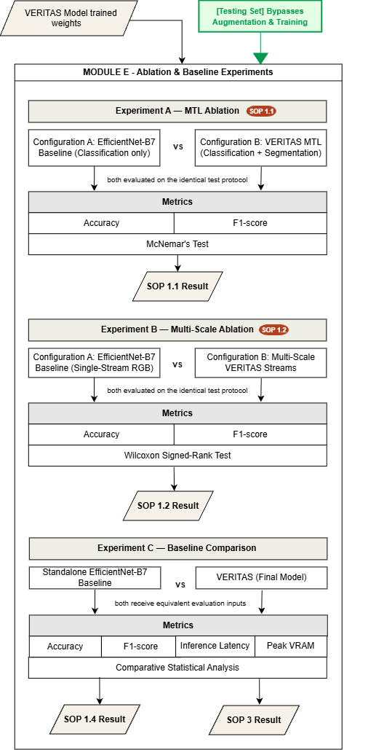
Figure 4.6: Ablation & Baseline Experiments
Module E is given the trained models generated by Module D for each of the three experimental setups (Configuration A, Configuration B, and the standalone EfficientNet-B7 baseline), and the held-out Testing Set passed from Module A, which provides the standard evaluation procedure with which all three experiments are evaluated.
The System Architecture identifies three controlled experiments that are tested using the same test protocol in each experiment, thereby enabling direct comparisons to be made. In Experiment A, the full VERITAS multi-task model (Configuration B) is trained against a classification-only EfficientNet-B7 (Configuration A), and to compare the two models, Accuracy and F1-score are evaluated using McNemar's Test, which is suitable for the two models being compared in this experiment because they are both trained on the same paired samples. To address SOP 1.2, Experiment B compares the single-stream RGB to the multi-modal, multi-scale VERITAS streams, and uses the Wilcoxon Signed-Rank Test to compare the Accuracy and F1-score distributions between the two streams. Experiment C targets SOP 1.4 and SOP 3, comparing not only Accuracy and F1-score, but also Inference Latency and Peak VRAM usage of the final VERITAS model to the standalone EfficientNet-B7 baseline reported by Eilia et al. (2025) under the same hardware setup. Once the mode’s performance has been tested, it will proceed to deployment.

- Deployed VERITAS System
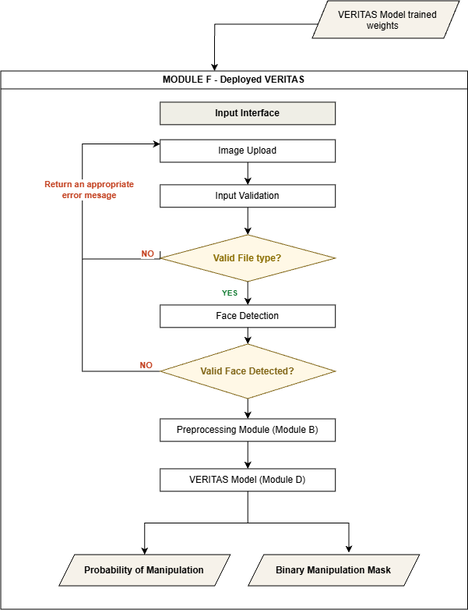
Figure 4.7: Deployed VERITAS
Module F receives two primary inputs: the finalized VERITAS Model trained weights transferred from the training and optimization environment, which configures the shared encoder and both task heads, and an image submitted by the user through the integrated Input Interface.
The Deployed Inference Engine reproduces the operational pipeline of Module B and Module D at inference time, but without any access to ground truth. The user-supplied image passes through input validation and face detection; a failed detection immediately triggers the same hard-stop behavior specified in the Conceptual Framework and returns a “No Face Detected” error to the interface. A successful detection proceeds through face cropping, standardization, normalization, and multi-modal feature generation before entering the packaged VERITAS encoder and its two heads. An integrated Runtime Error-Handling process enumerates the remaining failure modes the pipeline must recognize: invalid files, unsupported image formats, and insufficient facial exposure, each of which is surfaced to the user rather than allowed to propagate silently into the encoder.
Successful inference yields four outputs: a manipulation probability, a predicted label, a predicted manipulation mask, and a highlighted manipulated region– the same four classes of output identified in Module D, now delivered without a corresponding loss computation. The manipulation probability, together with the shared feature representation and the predicted manipulation mask, is processed by the integrated Explainability Engine (using the guid-Xmage strategy) to calculate pixel-level attribution; the classification probability, predicted binary mask, and explainability heatmaps are then output directly to the Results Dashboard.

Explainability Engine
Operationalizing the Explainable AI and Symbolic Execution Theory discussed in Chapter I, the Explainability Engine applies the guid-Xmage symbolic-execution strategy (Zhang et al., 2026) to generate a pixel-level contribution matrix identifying which pixels most influenced the classification verdict. This attribution map is combined with the predicted manipulation mask to form the Forensic Explanation Layer, the GUI’s Results Dashboard. Because guid-Xmage substitutes symbolic variables for pixel values and resolves non-deterministic operations using the execution trail of the actual input, its output is mathematically consistent with the model’s internal decision logic rather than being a post-hoc approximation, distinguishing it from gradient-based methods such as Grad-CAM.

GUI Layer - VERITAS Forensic Analysis GUI
The VERITAS Forensic Analysis GUI is the only component of the system that a forensic end user directly interacts with. Its Input Interface accepts an image upload, preview, and an Analyze action. Its Processing Status panel surfaces face-detection status, analysis progress, and any error messages raised by the integrated Input Validation and Face Detection processes. Once inference completes, the Results Dashboard presents four coordinated panels: an Authentication Result (the authenticity verdict and probability score), a Localization Result (the original image, predicted mask, and mask overlay), an Explainability Result (the attribution visualization), and Analysis Information (processing time and model/version identifier). This separation ensures that the interface a journalist, investigator, or other stakeholder consults is fed entirely by the deployed, ground-truth-free inference path described above.
The four consolidated panels are output as a single interactive view to the end user and are simultaneously consolidated into the final Forensic Analysis Report.

Forensic Output
Four result panels are then consolidated for the output: the Authentication Result, the Localization Result, the Explainability Result, and Analysis Information, and consolidates them into a single, human-readable Forensic Analysis Report comprising the input image, the detected face crop, the authenticity classification and its associated probability, the highlighted manipulation region, the segmentation mask, the explainability visualization, the measured inference latency, and the overall processing status. Because this report is generated entirely within the Deployed Inference Environment, it never contains ground-truth labels or ground-truth masks. Those references exist only within the Offline Research and Training Environment described in Modules A through E, preserving the architectural separation between how VERITAS is scientifically optimized and evaluated and how the resulting model is actually used. As the terminal deliverable of the System Architecture, the Forensic Analysis Report is output directly to the forensic investigator or other end user who initiated the analysis.

Architectural Feedback Loops
Four recursive structures distinguish this System Architecture from a simple forward pipeline. Loop 1 (Training Optimization), housed within Module D, carries the weighted total loss back through backpropagation to update the shared encoder on every training iteration. Loop 2 (Hyperparameter Optimization), spanning Modules C and D, cycles a candidate configuration through training and validation, aggregates its performance, and either proposes a new configuration or terminates the search, directly instantiating SOP 1.3. Loop 3 (Model Selection), which bridges Modules C and D, aggregates the validation results of all training runs to select the best hyperparameter configuration and trained weights, instantiating the finalized candidate model. Loop 4 (Research Comparison) is the pattern shared by all three experiments in Module E: a model variant is scored on the test protocol, compared statistically, and resolved into a specific SOP result. None of these loops draw upon the held-out Testing Set, completely preserving the integrity of the study's final performance claims.

SOP Traceability Summary
Table 3.x below (see the accompanying System Architecture diagram) maps each Statement of the Problem to the specific module responsible for answering it: SOP 1.1 to the MTL-versus-classification-only comparison in Module E; SOP 1.2 to the multi-scale stream design in Module D and its corresponding ablation in Module E; SOP 1.3 to the hyperparameter and weighted-loss optimization loop spanning Modules C and D; SOP 1.4 to the baseline comparison in Module E; SOP 2 to the segmentation evaluation (mIoU and Dice Coefficient) conducted using the test set in Module E; and SOP 3 to the computational benchmarking (Inference Latency and Peak VRAM) evaluated under Experiment C in Module E. This traceability confirms that the proposed system architecture is capable, by construction, of generating evidence for every research question posed in Chapter I.

- Test Cases
- This section discusses the test cases used in the study.
- The modules must be well-defined in terms of their expected inputs, processes, and outputs, so that each module is unambiguously specified and can be systematically developed and tested

- System Demo
- This section discuss and visualize the inputs and outputs of each step in the system
- It contained the images before and after the processing techniques.
- It include the snippets of the codes used to complete the process.
- Results and Analysis
- This section contains the discussion of the results in (a) training, (b) testing & validation (c) statistical analysis.
- Mostly it contain tables and text with explanation. You can also include relevant visualization to further explain the results n thereaders.

Chapter V: Presentation and Analysis of Data
- Summary of Findings
- This section is based on the results obtained in the last section of chapter 4.
- The discussion of summary of the findings gathered in the experiment will be presented.
- No conclusion can be drawn under this section.
- Conclusion
- This section must be based on the summary of findings.
- Make sure to revisit the SOP/ Objectives and verify if the conclusion is parallel to that section.
- Recommendations
- This must be based on the challenges encountered while performing the experiment.
- You need to state the possible solution that you have encountered while performing the proposed methods.
- This will help the future researchers to improve the current result of your study

